Core Banking – Global Solution Delivery
Baseline Functional Specification
Automatic Funds Transfer (Sweeps)
Table of Contents
Document ID | Automatic Funds Transfer BFS
Process | Analysis / Design
Status | Working Draft  Under Peer Review  Approved
Date Last Updated | 27/08/2013
1 Overview 3
1.1 Purpose 3
1.2 Definitions 3
1.3 Related References 3
2 Introduction 4
2.1 Overview 4
2.2 Diagram Overview 4
2.3 Scope 5
2.4 Assumptions 5
2.5 Exclusions 5
2.6 Regulatory Requirements 5
3 Business Functional System Specification 6
3.1 Originating Accounts 6
3.2 Relating Accounts 6
3.3 Target Balance Driver Functions 6
3.4 Uncleared Funds and Sweeps 7
3.5 Execution Sequence Code 9
3.6 Establishment of AFT 9
3.7 Maintenance of Sweeps 9
3.8 Details on Statements 9
4 Screens 10
4.1 Screen References 10
4.2 Screen Flow Diagram 10
5 Letters / Notices 11
5.1 Letter / Notice References 11
5.2 Letter / Notice Flow Diagram 11
6 Reports 12
6.1 Report References 12
7 PCD / Parameter Tables 13
7.1 PCD / Parameter Table References 13
8 Interfaces 14
8.1 Online 14
8.2 Batch 14
9 Testing Considerations 15
9.1 Hints and Tips 15
10 Summary of Amendments 16

Overview

Purpose
The purpose of this document is to provide a hierarchical view of a system’s business functionality. The view is composed of several levels, each level representing a decomposition of the one above and showing more detailed functionality. Within the baseline, each group represents a discrete set of functions, with each belonging to one and only one grouping.
This is a living reference document, which needs to be updated for changes / enhancements made to the function(s) described within.
Refer to the Baseline Documentation page on Core Banking myTeam sharepoint site for guidelines on how to update this document and for a description of the Baseline Documentation Process.

Definitions
The Core Banking (CB) Glossary of Terms is available as a link from the sharepoint Max site.

Related References
Document | Description
CACHE Reports Manual | (PVCS) X:\Project\CACHE _ORION\Baseline Documentation\CACHE\BFS
CACHE Fees BFS | (PVCS) X:\Project\CACHE _ORION\Baseline Documentation\CACHE\BFS
CACHE Screens BFS | (PVCS) X:\Project\CACHE _ORION\Baseline Documentation\CACHE\BFS

Introduction
This document describes the functionality of Automatic Funds Transfer also known as Sweeps in CACHE.

Overview
- The AFT transfers balances automatically from one current account to another current account (CABIs and CANBIs).
- DP00 and DP02 screens are used to set up and inquiry of the accounts involved in Sweeps.
- The transfer amounts can vary and occur as a result of certain conditions.
- The daily transfer limit on an account is $999,999,999.99.
- Sweeps process after all transactions (except taxes, fees and interest) are posted to the account and operate regardless of State public holidays.
- Trust accounts must not be included in any Sweep arrangements.
- ANZ Premium Cash Accounts, One Day Term Deposits Accounts and Short Term Accounts must not be included in any Sweep arrangements.
- Target Balance:
- Allowable Difference and Transfer Increments

Diagram Overview
Following are some of the examples of different type of Sweep Arrangements:

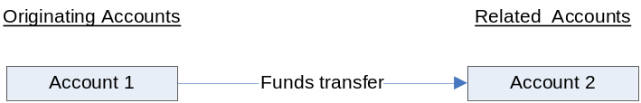
Figure 1: AFT Arrangement with one Originating and one Related Account

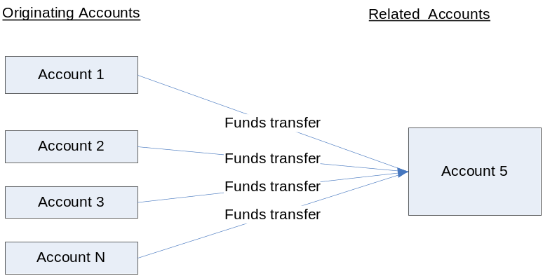
Figure 2A: AFT Arrangement with multiple Originating and one Related Account –Funds transferred to related accounts.

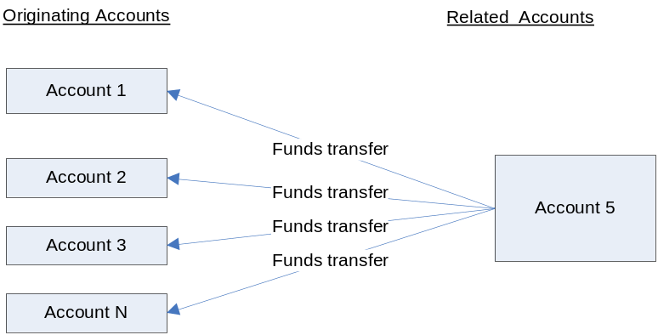
Figure 2B: AFT Arrangement with multiple Originating and one Related Account – Funds transferred to Originating accounts.

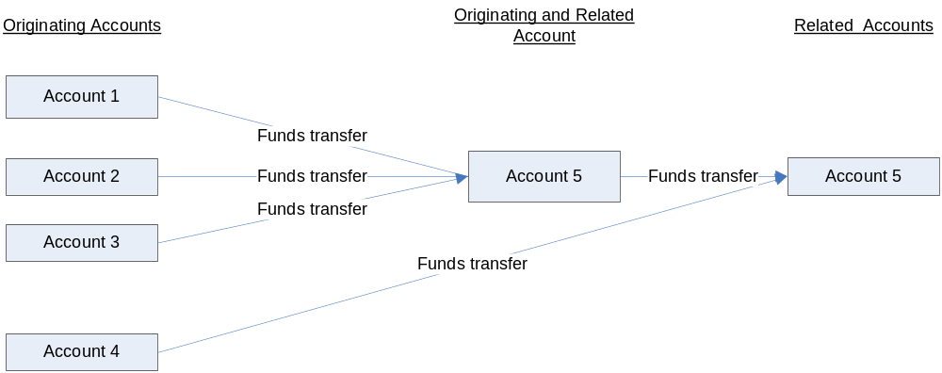
Figure 3: AFT Arrangement with the account acting as Originated and Related Account.

Scope
Driver Processing Valid Sub Product Codes:

DDA-Sub-Product Codes that can be Originating Account:
00, 01, 02, 04, 07, 08, 32, 50, 51, 52, 53, 54, 55, 58, 59, 60, 70, 89, 99.

DDA-Sub-Product Codes that can be Related Account:
00, 01, 02, 04, 07, 08, 50, 51, 52, 53, 54, 55, 58, 59, 60, 70, 89, 99.

Above information sourced from: PEND.PROD.CACHE.COPYLIB(X50025D)
- VALID-CA-01-SUB-PRD-ORG
- VALID-CA-01-SUB-PRD-REL

Assumptions
None.

Exclusions
- Currently, there is no functionality within CACHE to automatically reverse sweep transactions. If there is a need to reverse a sweep transaction, it will be performed as a transfer of funds via DBD$ and the float will be adjusted manually via DD18 screen.

Regulatory Requirements
No regulatory requirements

Business Functional System Specification

Originating Accounts
- Originating Account is the account for which target balance is set.
- The Originating Accounts initiates the transfer of funds which can be transferred out of Originating accounts or funds transferred in to Originating accounts to meet the nominated account balance.

Accounts which sweep to zero every night (i.e. ‘Target Balance’, ‘Allowable Difference’ and ‘Transfer Increment’ are all zero):
- If the ‘Originating Account’ has the ‘Instruction Code’ of Z or E (equal to ‘0’) i.e. sweeps to zero every night then,
  - The ‘debit and credit interest code’ for ‘Originating account’ must be ‘00’.
  - The “Penalty Interest” field must be set to ‘N’.
  - The account must have fees, government taxes and duties must be debited to a third party account to ensure the balance remains at zero.

Accounts which sweep to zero whenever the account is in debit (i.e. ‘Target Balance’, ‘Allowable Difference’ and ‘Transfer Increment’ are all zero):
- If the ‘Originating Account’ has the ‘Instruction Code’ of ‘L’ and the nominated ‘target balance amount’ is 0 i.e. account sweeps to zero whenever the account is in debit then,
  - The ‘debit interest code’ for ‘Originating account’ must be ‘00’.
  - The “Penalty Interest” field must be set to ‘N’.

Accounts which sweep to zero whenever the account is in credit (i.e. ‘Target Balance’, ‘Allowable Difference’ and ‘Transfer Increment’ are all zero):
- If the ‘Originating Account’ has the Instruction Code of ‘G’ and the nominated ‘target balance amount’ is 0 i.e. account sweeps to zero whenever the account is in credit then,
  - The ‘Credit interest code’ for Originating Account must be ‘00’.
- Sweep accounts which have conditions other than the above must have standard debtor and creditor interest codes recorded.

Relating Accounts
- Related accounts are credited or debited by Originating accounts to meet the nominated ‘account balance’ on the ‘Originating account’.

Driver Sequence Number
- When more than one driver is present on an account, each driver operates in sequence according to its ‘driver sequence number’.
- The driver sequence number determines the order in which transfer in or transfer out (from Originating to Related Account or vice versa to meet the target balance) will occur.
- If multiple target balance drivers exist on the Originating account, they operate in order of lowest to highest sequence number.

Related Execution Sequence Number
- This field is only completed if ‘Y’ is entered in the ‘EXECUTION PROCESSING SEQ CODE’ field.
- Enter the next sequence number for the ‘Related account’.
- This number represents the order in which different Originating accounts debit or credit funds from/to the Related account.

Execution Processing Sequence Code
- When “Y” is entered, this field will use the “Related Execution Sequence Number” field when more than 1 ‘Originating Account’ uses the ‘Related Account’ for Crediting or Debiting funds.
- The default value for this field is “N”.

Common Ownership
- This field is used to identify if the Originating and Related accounts are owned by the same customer.
- Default value for this field is “Y”, assuming the Originating and Related account are owned by the same customer.
- If the Originating and Related account are not owned by the same customer, enter “N”.

Target Balance Driver Functions
- The Target Balance Driver initiates and controls the movement of funds at the end of the day from one account to another to attain the desired ‘target balance amount’ on the ‘Originating account’.
- An account can participate as an ‘Originating account’ or ‘Related account’ in more than one driver instruction.
- A TB Driver ‘Instruction Code’ must be established on the ‘Originating account’ to transfer funds to and from the ‘Related account’ and operates as follows:
  - An account must be designated as an Originating account and a nominated ‘target balance amount’ established for the account.
  - A separate account must be designated as a ‘Related account’. This account is debited or credited by the ‘Originating account’ in terms of the sweep arrangement.
- Instruction Code: Following are the different types of driver Instruction Codes that can be loaded in ‘Originating Account’:
  - Code G (Greater Than):
    - If the ‘Originating account’ has the ‘Instruction Code’ of ‘G’ recorded on it and the balance in the Originating account is greater than the nominated ‘target balance amount’, the surplus funds are transferred to the ‘Related account’.
  - Code L (Less Than):
    - If the ‘Originating account’ has the ‘Instruction Code’ of ‘L’ recorded on it and the balance in the ‘Originating account’ is less than the nominated ‘target balance amount’, funds are transferred from the ‘Related account’ to the ‘Originating account’ to increase the balance to the nominated balance.
  - Code E (Equal to):
    - If the ‘Originating account’ has the ‘Instruction Code’ of ‘E’ recorded on it, funds are transferred to or from the ‘Related account’ to maintain the nominated ‘target balance amount’ in the Originating account.
  - Code Z (Zero Balance):
    - If the ‘Originating account’ has the ‘Instruction Code’ of ‘Z’ recorded on it, the nominated ‘target balance amount’ established for the ‘Originating account’ is zero. Funds are transferred to or from the ‘Originating account’ to maintain a zero balance. When using the Instruction code of ‘Z’, fees and interest on the ‘Originating account’ must be charged to a third party account.

Uncleared Funds and Sweeps
- Sweep processing uses Current Balance when transferring funds from one account to another.
- The float adjustment increase is processed to the account (either originating or related) where the credit funds are processed:
  - When ‘originating account’ is debited & related account is credited, float is decreased on ‘originating account’ and increased on related account.
  - When ‘originating account’ is credited & related account is debited, float is increased on ‘originating account’ and decreased on related account.
- The Uncleared Funds Tolerance Threshold is not referenced during sweep processing (i.e. Uncleared Funds Tolerance Threshold does not impact sweeps).
- If the sweep results in a debit being posted on either the originating or related account as a transfer of funds, the available balance check is not invoked and the transaction is posted.
  - If the OBP Code is 03, 63 or 83 and the related account doesn’t have sufficient funds then the sweep transaction is posted as there is no available funds check performed. This results in the target balance being achieved.
  - If the OBP code is 61 or 81 and the related account doesn’t have sufficient funds then the sweep transaction is processed and is not reported as a posted item in OTP.
- Dishonour transactions are processed as per the special instructions loaded at the time of dishonour.
- The sweeping of either uncleared or cleared funds first is determined by the value in the “BALANCE CODE” field in CACHE DP00 screen. It also determines the order in which the float is moved between the accounts in a sweep arrangement.
- Following are the two types of balance code that can be loaded in ‘Originating Account’:
  - Balance Code “U”:
    - If the ‘Originating account’ has Balance Code “U” loaded on it and originated account is debited (i.e. related account is credited):
      - The uncleared funds are swept from originating account before any cleared funds.
      - When uncleared funds are swept from originating account to related account, the uncleared funds are swept in order of descending days i.e. total from day 5 first, then day 4 and so on until the target balance is met. This is also reflected in the related account in descending order.
    - If the ‘originating account’ has Balance Code “U” loaded on it and ‘originated account’ is credited (i.e. related account is debited):
      - The cleared funds are swept from related account before any uncleared funds.
      - When uncleared funds are swept from related account to originating account, the uncleared funds are swept in order of ascending days i.e. total from day 1 first, then day 2 and so on until the target balance is met. This is also reflected in the ‘originating account’ in ascending order.
  - Balance Code “A”:
    - If the ‘originating account’ has ‘Balance Code’ “A” loaded on it and ‘originated account’ is debited (i.e. ‘related account’ is credited):
      - The cleared funds are swept from ‘originating account’ before any uncleared funds.
      - When uncleared funds are swept from ‘originating account’ to ‘related account’, the uncleared funds are swept in order of ascending days i.e. total from day 1 first, then day 2 and so on. This is also reflected in the ‘related account’ in ascending order.
    - If the ‘originating account’ has Balance Code “A” loaded on it and ‘originated account’ is credited (i.e. ‘related account is debited):
      - The uncleared funds are swept from related account’ before any cleared funds.
      - When uncleared funds are swept from ‘related account’ to ‘originating account’, the uncleared funds are swept in order of descending days i.e. total from day 5 first, then day 4 and so on. This is also reflected in the originating account in descending order.
- The default value for BALANCE CODE is U.
- All OBP codes (i.e. 01, 03, 61, 63, 81 & 83) are valid for BALANCE CODE U & A.
- If a value other than U or A is entered into the BALANCE CODE field; then an error message - Invalid Balance Code is displayed.

Establishment of AFT
Following steps will need to be performed in order to establish an automatic funds transfer (sweep arrangement):
- Access the CACHE DP00 screen.
- Enter ‘ADD’ in the ACTION field.
- Enter the DRIVER TYPE as ‘TB’.
- Enter the Originating & Related Account number.
- If sweep instruction for the account already exists, enter the appropriate value for “Driver Sequence Number”.
- If there is already an ‘Originating Account’ attached to the nominated ‘Related Account’, enter the next available sequence number in the “Related Exec Sequence No.” field, otherwise leave blank.
- If there is more than 1 ‘Originating account’ using the ‘Related account’ enter “Y” in the “Execution Processing Seq. Code” field, otherwise leave to default to blank.
- If the Originating and Related accounts are not shared by the same customer, enter “N” in the Common Ownership field, otherwise leave to default to “N”.
- Enter the ‘Instruction Code for the sweep arrangement.
- If applicable, enter the Target Balance amount, Allowable Difference, Transfer Increment & Daily Transfer Limit into the appropriate fields.
- Enter the appropriate ‘Balance Code’ for the sweep arrangement. This will drive the order in which Uncleared Funds are moved as a result of the sweeping of funds.
- If a Sweep Establishment Fee is applicable, enter the amount in the “Sweep Establish Fee Amt” field and enter “Y” in the “Charge Fee (Y/N)” field.
- If a Sweep Establishment Fee is not applicable, enter “N” in the “Charge Fee (Y/N)” field.

Maintenance of Sweeps
Sweep arrangements can be maintained via the DP00 screen.
Following steps will need to be performed in order to maintain an existing automatic funds transfer (sweep arrangement):
- Access the CACHE DP00 screen.
- Enter ‘INQ’ in the ACTION field and enter the details of the sweep arrangement to be changed.
- Enter ‘CHG’ in the ACTION field.
- Amend the relevant fields required and press <enter>.
- The changes will be reflected on the DP00 screen immediately.
- The changes will take affect from the next time the sweep arrangement is executed (i.e. next CACHE batch cycle).

Sweep arrangements can be deleted via the DP00 screen.
Following steps will need to be performed in order to delete an existing automatic funds transfer (sweep arrangement):
- Access the CACHE DP00 screen.
- Enter ‘INQ’ in the ACTION field and enter the details of the sweep arrangement to be deleted.
- Enter ‘CHG’ in the ACTION field and press <enter>.
- The sweep arrangement will be deleted from the DP00 screen immediately.
- The deleted sweep arrangement will not be executed during the next CACHE batch cycle.

Sweep Fees
There are currently two types of sweep arrangement fees charged;
- Sweep Establishment Fee
- Sweep Service Fee

Sweep Establishment Fee
- Sweep Establishment Fee is applicable when a new sweep arrangement is created and is a once off fee.
- Sweep Establishment Fee amount is entered on the CACHE DP00 screen in the ‘SWEEP ESTABLISHMENT FEE AMT’ field.
- To enable the fee to be charged, the user will enter ‘Y’ in the ‘CHARGE FEE (Y/N)’ field on CACHE DP00 screen.
- The fee will charge to the originating account in the sweep arrangement during the nightly batch.

Sweep Service Fee
- Sweep Service Fee applies every time the account is an ‘originating account’ for a sweep arrangement.
  - ‘No. Of Items’ field on CACHE DD02 screen is incremented by 1 for every sweep arrangement where the account is the originating account, regardless if the sweep has executed or not.
  - At the end of the cycle period, CACHE will perform the calculation (No. of Items X Amt Per Item) and charge off the fee to the originating account of the sweep arrangement.
- The ‘No. Of Items’ field on CACHE DD02 screen will be reset to zero (blank) once the Sweep Service Fee has been cycled.

Details on Statements
Sweep transactions appear on customer’s statements as follows:
Originating account:
Short Description: A.F.T.
Related account:
A symbol indicating the capital city (A – Adelaide, B – Brisbane, etc) in the domicile State of the Originating account and its account number, eg ‘A123456789’.

Originating Accounts with more than one Driver
- In order to meet the customer’s requirements for the account, some sweep arrangements requires more than one driver. For Example, a customer may request debit balances on an account to be swept to zero, and credit balances above $1,000 to be swept to $1,000. To achieve this, one driver must be set up for each condition, as detailed below:
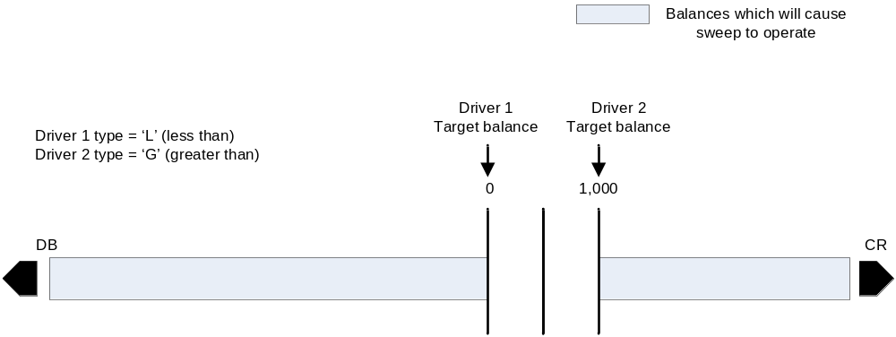
- If a ‘Transfer Increment’ is specified, funds are transferred to or from the Originating account in specified amounts until the ‘Target Balance amount’ is met or over taken, whichever is first.
- If an ‘Allowable Difference’ is specified, the sweep will not operate until the difference between the Originating account’s balance and its ‘Target Balance amount’ is greater than the ‘Allowable Difference’. When this condition is met, the account sweeps to the Target Balance as shown below:

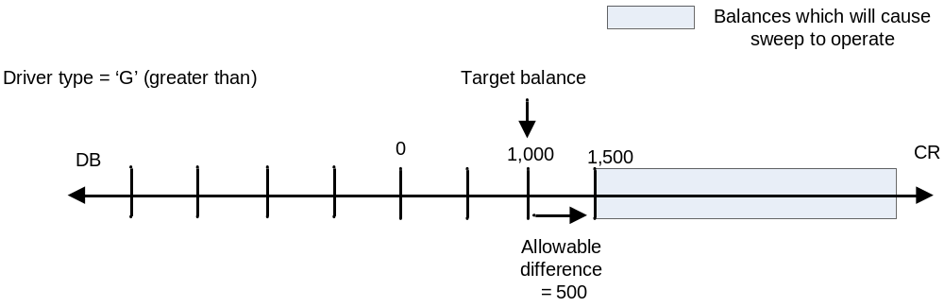

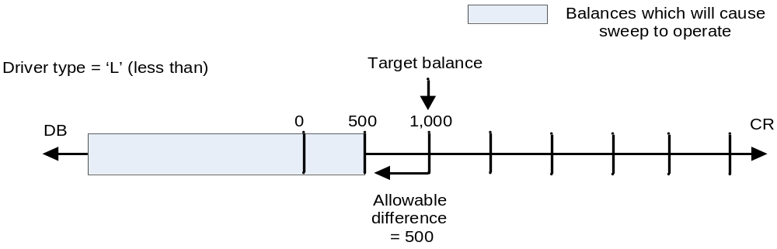

- The Allowable Difference works in opposite directions for ‘G’ and ‘L’ driver types.
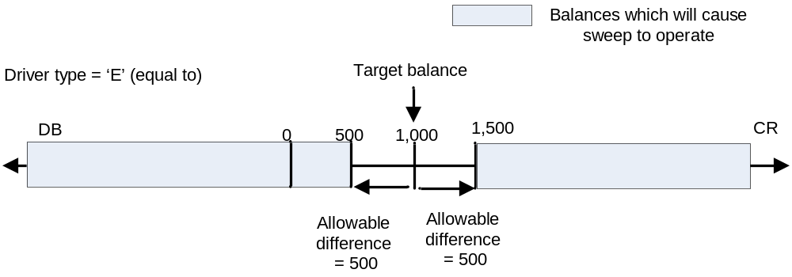

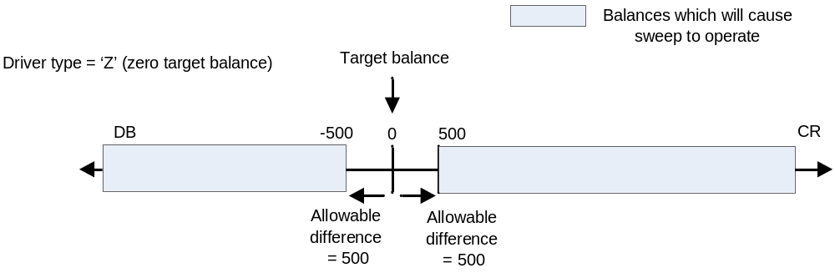
- The Allowable Difference works both ways for ‘E’ and ‘Z’ Driver Types. If the Target Balance had been set to ‘0’ for Driver Type ‘E’, it would be equivalent to Driver Type ‘Z’.

Screens

Screen References

Screen ID | Screen Name | Brief Description | Document Link
DP00 | DRIVER PROCESSING INQ/SETUP | Screen used to inquiry, maintain and create driver processing (Sweep) instructions for DDA accounts. | Refer to PVCS\CACHE_ORION\Baseline Documentation\CACHE\BFS\CACHE Screens BFS.doc
DP02 | DRIVER PROCESSING INQUIRY | Screen used to inquire and display Originating and Related drivers connected to a DDA account. | Refer to PVCS\CACHE_ORION\Baseline Documentation\CACHE\BFS\CACHE Screens BFS.doc
DD05 | DRIVER INFORMATION ORIGINATING ACCT | Screen used to display driver (Sweep) information on an originating account. | Refer to PVCS\CACHE_ORION\Baseline Documentation\CACHE\BFS\CACHE Screens BFS.doc

Screen Flow Diagram
Not Applicable

Letters / Notices

Letter / Notice References

Letter / Notice ID | Letter / Notice Name | Brief Description | Online/Batch | Brief Description | Document Link
Not Applicable

Letter / Notice Flow Diagram
Not Applicable

Reports

Report References

Report ID | Report Name | Brief Description | Document Link
CR0090 | DDA Target Balance Relationships | Reports sweep accounts with Target Balance Relationship | Refer to PVCS\CACHE_ORION\Baseline Documentation\CACHE\BFS\CACHE Reports Manual.doc
CR0091 | DDA Driver Relationship | Reports new, maintained, and incorrect driver relationships. | Refer to PVCS\CACHE_ORION\Baseline Documentation\CACHE\BFS\CACHE Reports Manual.doc
CR0290 | Online Maintenance Audit Journal | Reports all on-line non-value maintenance (except lending data and changes to interest rate/codes) on DDA accounts performed via the Integrated Deposit System (IDS) and the Customer Information System (CIS) for ABN/TFNs. | Refer to PVCS\CACHE_ORION\Baseline Documentation\CACHE\BFS\CACHE Reports Manual.doc

PCD / Parameter Tables

PCD / Parameter Table References

PCD / Parameter ID | PCD / Parameter Type | PCD / Parameter Name | Brief Description | Document Link
Not Applicable

Interfaces

Online
Interface ID | Interface Type | Interface Name | Document Link
Not Applicable

Batch
Interface ID | Interface Type | Interface Name | Document Link
Not Applicable

Testing Considerations

Hints and Tips

Summary of Amendments
Additional amendments must be added after the previous amendment.
Date | Section | WR/AHD# | Implementation release and date | Author | Brief description of change
14/10/2011 | All | N/A | N/A | Sunil Awale | Initial Version
02/05/2012 | 2.3 | N/A | N/A | John Kirk | Valid Sub Product list added to scope.
16/08/2012 | All | N/A | N/A | Brad Adams | Finalised draft version of the document.
08/10/2012 | All | N/A | N/A | Sri Naga | Minor spelling changes
27/08/2013 | 2.3 | WR22352 DDA 60 Parameter Changes | Rel 13.6 12/10/2013 | Kelly Sabatino | Added DDA 60 as a valid sub product for an originating account.

